План- конспект уроку 6 клас
(учитель Обуховська Т.Є)
Підручник: О.Д. Карп’юк
Тема: Види магазинів. Ступені порівняння прикметників.
Цілі:
Практичні: навчити учнів розуміти на слух і вживати в мовленні на рівні фрази лексичні одиниці для розмови про магазин: at the baker’s, at the butcher’s, in the greengrocery, in the grocery; активізувати знання учнів з граматики, вживання структур: Where can I buy…?, I can buy…, They sell …; повторити способи утворення ступенів порівняння простих прикметників; познайомити учнів з прикметниками-вийнятками; вчити учнів вести монологи та діалоги у зв’язку з запропонованими ситуаціями;
Загальноосвітні: розширити іншомовну лексичну компетенцію учнів;
Розвивальні: розвивати навички усного мовлення учнів, навички читання, аудіювання та письма, вміння переносити знання та навички в нову мовну ситуацію, розвивати мовну здогадку та мовленнєву реакцію учнів, їх швидкість та критичність мислення, стійку увагу та творчу уяву;
Виховні: виховувати інтерес до вивчення англійської мови, загальну культуру учнів, почуття відповідальності та доброзичливості.
Обладнання: наочний матеріал, технічні засоби навчання, роздавальний матеріал.

Хід уроку
І. Початок уроку
1. Організаційна частина (greeting).
-Good morning, dear children!
- How are you?
- Let’s start our lesson. Are you ready?
2. Фонетична зарядка (pronunciation).
- Look at the blackboard. Let’s do some exercises for our tongues and remember reading rules.
1) th [ð] the, this, that, than;
2) th [Ө] thin, thick, toothpaste;
3) sh [∫] shop, shirt, short;
4) igh [ai] light, night, high.
3. Мовна зарядка (warm-up).
- Look at the blackboard and tell me, please, what kind of shop is this?
(This is a bakery.(grocer, greengrocer, butcher).
Work in groups.
- Now let’s fall into two groups. You see the words on the blackboard. You must put these words under correct kind of shop.
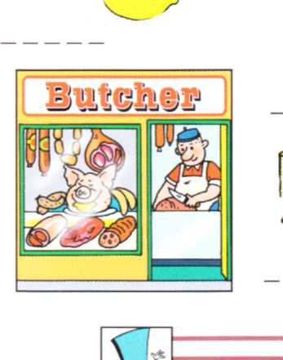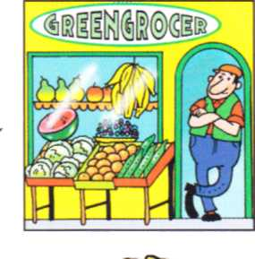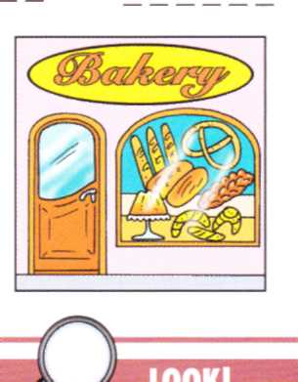
meat potatoes cakes
chicken tomatoes biscuits
sausages onions pies
cucumbers rolls
lemons
oranges buns

- O. k. Let’s remember:
1. What can we buy at the bakery?
2. What do they sell at the butcher’s?
Work in pairs.
Ask and answer.
Where can I buy apples? – You can buy apples in the greengrocers.
ІІ. Основна частина уроку.
1. Перевірка домашнього завдання (check on homework)
-You must compare children using the words taller and shorter from the box.
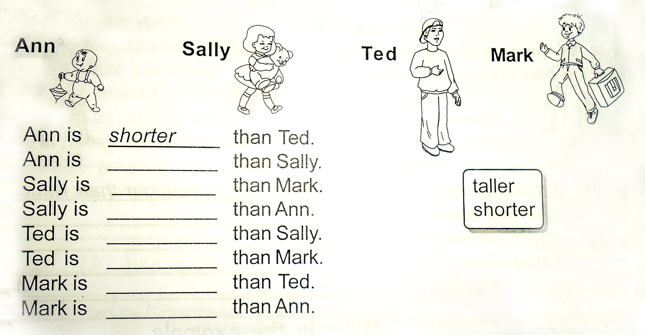

2. Повідомлення теми та мети уроку (aim).
- Today we will continue to speak about shops and shopping. And remember adjectives and their degrees.
3. Вивчення нового матеріалу (warming-up).
- Let’s remember, what comparison degrees has adjective.
(Презентація. Розглядаємо і повторюємо).
Work in groups.
Ex.2 p. 28 (робочий зошит до підручника)
a) big – bigger – the biggest b) heavy – heavier – the heaviest
hot – hotter – ________ easy – easier - _______
wet - ________ - _________ happy - ________ - _______

Work in cards. (Учні самостійно виконують в зошитах)

1 ) Look at the pictures and complete the sentences.

1.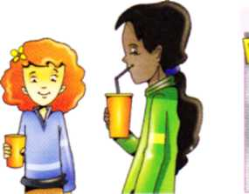 2. 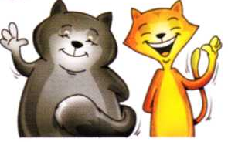 3. 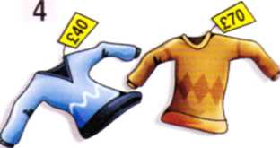

1. Jane is taller than Kelly. (tall)

2. The red cat is …….. than the black cat. (thin)

3. The blue sweater is ………than the brown one. (cheap)

1 ) Look at the pictures and complete the sentences.

1.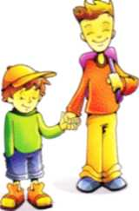 2.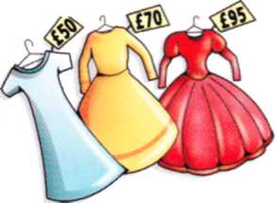 3.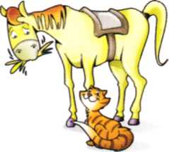

1. Tom is taller than John. (tall)

2. The blue dress is the …….. of all. (cheap)

3. A horse is …….. than a cat. (big)
4. Фізкультхвилинка (physical activity).
And now let’s have a rest and sing a song “Ten drown buns in the baker’s shop”

Ten brown buns in the baker’s shop
Round and fat with sugar on the top.
A little girl came with a penny one day,
She bought one bun and took it right away.

Nine brown buns in the baker’s shop
Round and fat with sugar on the top.
A little boy came with a penny one day,
He bought one bun and took it right away.
Eight brown buns in the baker’s shop
- - - - - - - - - - - - - - - - - - - - - - - - - - -
No brown buns in the baker’s shop
Round and fat with sugar on the top.
A little girl came with a penny one day,
There were no brown buns for her to take away.

A little girl came with a penny one day,
There were no brown buns for her to take away.
5. – Today we learn some irregular adjectives. They are: good and bad. (Презентація 2)
6. Закріплення вивченого матеріалу (reinforcement).
Ex. 1 p. 30. Complete the sentences as in the example.
Ex. 9 p. 47. Listen to the story “The Dearest Toy” and complete the sentences.
THE DEAREST TOY
When I was a little boy my grandpa came to visit us in the city. One day he took me to the toyshop. The best toys for me were to cars, of course. There were lots of toy cars in the shop. I took the green toy car and looked around. It was better than the yellow car but worse than the blue one. I took the blue car. Suddenly I saw the brown bike in the corner. I wanted to have a bike. Which Jone is better? The red bike was nicer than the brown one... Then my eye stopped at the beautiful kite. It was red and white. It was smaller and cheaper than the yellow and green one next to it, but it was lighter and better. I liked it very much. My grandpa bought it for me. The next day we flew the kite with my grandpa. I remember that day. It was the best day in my life. And this kite was the dearest _{u} toy for me. Now it is the oldest toy in my house but it’s still the best toy for my sons, too. We like flying it at weekends. At these moments I feel myself younger.

- When I was a small boy the best toys for me were (toy cars/ toy buses).
- The green toy car was (the best/ better) than the yellow one, but (worse/ the worst) than the blue toy car.
- The red bike was (the nicest/ nicer) than the brown bike.
- The red and white kite was (smaller/ the smallest) and (cheaper/ the cheapest) than the yellow and blue one.
- The day we flew the kite with my grandpa was (better/ the best) day in my life.
- The kite is the (dearer/ dearest) toy for my son.
- When we fly it at weekends I feel myself (young/ younger).

ІІІ. Заключна частина.
1. Підведення підсумків уроку (summarizing).
Check your answers. Count correct answers p 21.
(Виставлення оцінок за урок)
-That’s all for today. Have a nice day! See you next time!
2. Домашнє завдання (homework).
Ex. 2 p. 30 ( Fill in with correct form of the adjectives from the box).

